Quiz 1 (CSE331L.7 – Asif Ahmed Neloy_Summer’20)

Department of Electrical and Computer Engineering

School of Engineering and Physical Sciences

North South University, Bashundhara, Dhaka-1229, Bangladesh

*Time 20 minutes, Marks 20 (You need to answer all questions).*

***Name – Tasnim Amin***

***ID - 1611226042***

1. **Why it is never a good idea to store any data in the segment registers?[5] -**

**Answer:** As we know this segment has its own address. It works easily and fast but the memory is divided in segment so it is nit good to save/store data in segment**.**

**0**

1. **Write a program in Assembly language that will add 4 integer number (1,2,2,1) using only AX register and Store the result in the AX register.**

**Answer: 0**

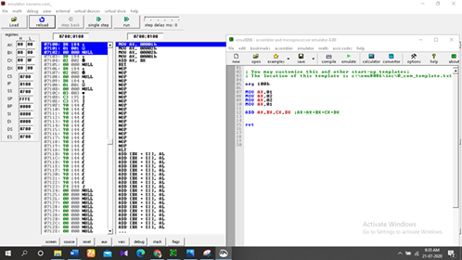

**End**